Heater/Vent Module Replacement

Heater/Vent Module Replacement
Removal Procedure
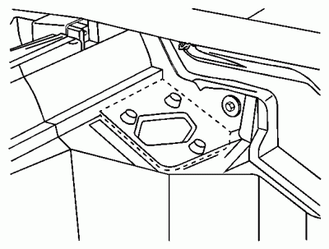
Click to Enlarge
- Remove the instrument panel. Refer to Instrument Panel Carrier Replacement in Instrument Panel, Gages and Console.
- Drain the engine coolant. Refer to Cooling System Draining and Filling in Engine Cooling.
- On vehicles with automatic climate control only, cut the outer layer of the A/C evaporator and blower module in order to access the service access cover.
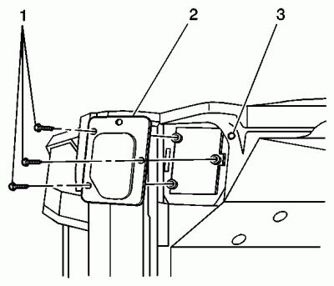
Click to Enlarge
- On vehicles with automatic climate control only, remove the service access cover mounting screws (1).
- On vehicles with automatic climate control only, remove the service access cover (2).
- On vehicles without automatic climate control, remove the blower motor resistor. Refer to Blower Motor Resistor Assembly Replacement (Refer To List 1) .
NOTE
Important: Mark and use the same mounting bolt for the heater/vent module during the installation process. Other mounting bolts are longer and will obstruct the operation of the temperature door.
- Remove the heat/vent module mounting bolt through the blower motor resistor or service access cover opening.
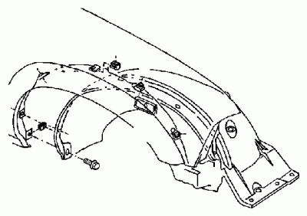
Click to Enlarge
- On vehicles with A/C only, remove the right wheel house panel. Refer to Wheelhouse Panel Replacement in Body Front End.
- On vehicles with A/C only, raise and support vehicle. Refer to Lifting and Jacking the Vehicle in General Information.
- On vehicles with A/C only, remove the front right tire. Refer to Tire and Wheel Removal and Installation in Tires and Wheels.
- On the Utility only, remove the A/C evaporator and blower module heat shield screws.
- On the Utility only, slide the A/C evaporator and blower module heat shield toward the front of the vehicle.
- Remove the 2 lower heat/vent module mounting nuts.
- On the Utility only, remove the A/C evaporator and blower module heat shield bracket.
- Remove the bottom right heat/vent module mounting bolt from inside the vehicle.
NOTE
Important: The heat/vent mounting stud has a flange on the inside and cannot be removed from under the hood. Stop turning the stud after the threads are off the heat/vent module.
- On the Utility only, while an assistant inside the vehicle pulls the bottom right corner of the heat/vent module approximately 2.5 mm (1 in) back, remove the 2 heat/vent module mounting studs.
- On vehicles with A/C only, lower the vehicle.
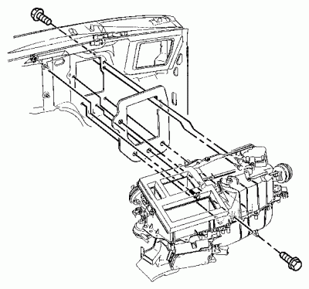
Click to Enlarge
- On vehicles with a 2.2 L engine only, remove the engine wiring harness bracket located at the rear of the intake manifold. Refer to Valve Rocker Arm Cover Replacement in Engine Mechanical - 2.2 L.
- Remove the HVAC module mounting bolt located at the lower left side of the heater core to heater hose connection.
- Remove the HVAC module mounting nut located at the lower right side of the heater core to heater connection.
NOTE
Important: The heat/vent mounting stud has a flange on the inside and cannot be removed from under the hood. Stop turning the stud after the threads are off the heat/vent module.
- On the Utility only, loosen the HVAC module mounting studs until the threads are free from the heat/vent module.
- Disconnect all of the electrical connectors from the HVAC module.
- Disconnect all of the vacuum lines from the heater assembly.
- Disconnect the heater hoses from the heater core.
- Remove the HVAC module from the vehicle.
Installation Procedure
Click to Enlarge
- If replacing the HVAC module, transfer the components from the old heat/vent module as necessary.
NOTE
Important: Before installing the HVAC module to the vehicle, ensure that the HVAC module mounting studs are located in the proper positions.
- Install the HVAC module to the vehicle.
- Connect the heater hoses to the heater core.
- Connect all of the vacuum lines to the heater assembly.
- Connect all of the electrical connectors to the HVAC module.
- Install the bottom right HVAC module mounting bolt from inside the vehicle approximately halfway into the threads.
NOTE
Notice: Use the correct fastener in the correct location. Replacement fasteners must be the correct part number for that application. Fasteners requiring replacement or fasteners requiring the use of thread locking compound or sealant are identified in the service procedure. Do not use paints, lubricants, or corrosion inhibitors on fasteners or fastener joint surfaces unless specified. These coatings affect fastener torque and joint clamping force and may damage the fastener. Use the correct tightening sequence and specifications when installing fasteners in order to avoid damage to parts and systems.
- On the Utility only, install the HVAC module mounting stud located at the lower right side of the heater core to heater hoses connection in the engine compartment.
Tighten
Tighten the HVAC module mounting stud to 4.5 N·m (40 lb in).
- On vehicles with A/C only, raise the vehicle. Refer to Lifting and Jacking the Vehicle in General Information.
- On the Utility only, install the bottom right HVAC mounting studs. Ask an assistant to pull the bottom right corner of the HVAC module back from inside the vehicle.
Tighten
Tighten the heat/vent module mounting studs to 4.5 N·m (40 lb in).
- On the Utility only, install the A/C evaporator and blower module heat shield bracket.
- Install the heater/vent module mounting nuts.
Tighten
Tighten the HVAC module mounting nuts to 4.5 N·m (40 lb in).
- On the Utility only, slide the A/C evaporator and blower module heat shield into the original position.
- On the Utility only, install the A/C evaporator and blower module heat shield screws.
Tighten
Tighten the A/C evaporator and blower module heat shield screws 2.2 N·m (19 lb in).
Click to Enlarge
- On vehicles with A/C only, install the right front tire. Refer to Tire and Wheel Removal and Installation in Tires and Wheels.
- On vehicles with A/C only, lower the vehicle.
- Install the bottom right HVAC module mounting bolt from inside the vehicle.
Tighten
Tighten the HVAC module mounting bolt to 4.5 N·m (40 lb in).
- On vehicles with A/C only, install the right wheel house panel. Refer to Wheelhouse Panel Replacement in Body Front End.
Click to Enlarge
- Install the HVAC module mounting nut located at the lower right side of the heater core to heater connection.
Tighten
Tighten the HVAC module mounting nut to 4.5 N·m (40 lb in).
- Install the HVAC module mounting bolt located at the lower left side of the heater core to heater hose connection.
Tighten
Tighten the HVAC module mounting bolt to 4.5 N·m (40 lb in).
- On vehicles with the 2.2 L engine only, install the engine wiring harness bracket located at the rear of the intake manifold. Refer to Valve Rocker Arm Cover Replacement in Engine Mechanical - 2.2 L.
NOTE
Important: Use the same mounting bolt marked during removal for the HVAC module during the installation process. Other mounting bolts are longer and will obstruct the operation of the temperature door.
- Install the HVAC module mounting bolt through the blower motor resistor or service access cover opening.
Tighten
Tighten the HVAC module mounting bolt to 4.5 N·m (40 lb in).
- On vehicles without automatic climate control, install the blower motor resistor. Refer to Blower Motor Resistor Assembly Replacement (Refer To List 1) .
Click to Enlarge
- On vehicles with automatic climate control only, install the service access cover (2).
- On vehicles with automatic climate control only, install the service access cover mounting screws (1).
Tighten
Tighten the screws to 1.9 N·m (17 lb in).
Click to Enlarge
- On vehicles with automatic climate control only, install the outer layer of the A/C evaporator and blower module.
NOTE
Important: Do not use RTV. Apply the adhesive bead as straight as possible. Allow the adhesive to set for 15 minutes or until the adhesive becomes tacky.
- Seal the cut line using black weather-strip adhesive.
- Refill the engine coolant. Refer to Cooling System Draining and Filling in Engine Cooling.
- Install the instrument panel. Refer to Instrument Panel Carrier Replacement in Instrument Panel, Gages and Console.
- Calibrate the HVAC module actuator. Refer to Actuator Recalibration in HVAC Systems - Automatic.

Refer To List:
List 1
- HVAC / Heating, Ventilation And Air Conditioning / Repair Instructions / Blower Motor Resistor Assembly Replacement (C60)
- HVAC / Heating, Ventilation And Air Conditioning / Repair Instructions / Blower Motor Resistor Assembly Replacement (C42)

Heater/Vent Module Replacement
Removal Procedure
- Remove the instrument panel. Refer to Instrument Panel Carrier Replacement in Instrument Panel, Gages and Console.
- Drain the engine coolant. Refer to Cooling System Draining and Filling in Engine Cooling.
- Cut the outer layer of the A/C evaporator and blower module in order to access the service access cover.
Click to Enlarge
- Remove the service access cover mounting screws (1).
- Remove the service access cover (2).
- Remove the blower motor resistor.
NOTE
Important: Mark and use the same mounting bolt for the heater/vent module during the installation process. Other mounting bolts are longer and will obstruct the operation of the temperature door.
- Remove the heat/vent module mounting bolt through the blower motor resistor or service access cover opening.
- Remove the left wheel house panel. Refer to Wheelhouse Panel Replacement in Body Front End.
- Raise and support vehicle. Refer to Lifting and Jacking the Vehicle in General Information.
- Remove the front left tire. Refer to Tire and Wheel Removal and Installation in Tires and Wheels.
- On the Utility only, remove the A/C evaporator and blower module heat shield screws.
- On the Utility only, slide the A/C evaporator and blower module heat shield toward the front of the vehicle.
- Remove the 2 lower heat/vent module mounting nuts.
- On the Utility only, remove the A/C evaporator and blower module heat shield bracket.
- Remove the bottom left heat/vent module mounting bolt from inside the vehicle.
NOTE
Important: The heat/vent mounting stud has a flange on the inside and cannot be removed from under the hood. Stop turning the stud after the threads are off the heat/vent module.
- On the Utility only, while an assistant inside the vehicle pulls the bottom right corner of the heat/vent module approximately 1 inch back, remove the 2 heat/vent module mounting studs.
- Lower the vehicle.
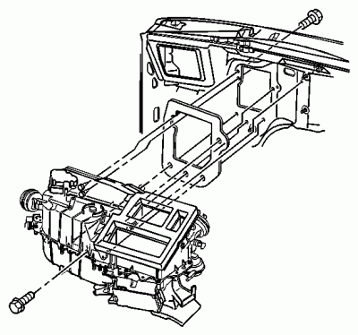
Click to Enlarge
- Remove the heat/vent module mounting bolt located at the lower left side of the heater core to heater hose connection.
- Remove the heat/vent module mounting nut located at the lower left side of the heater core to heater connection.
NOTE
Important: The heat/vent mounting stud has a flange on the inside and cannot be removed from under the hood. Stop turning the stud after the threads are off the heat/vent module.
- On the Utility only, loosen the heat/vent module mounting studs until the threads are free from the heat/vent module.
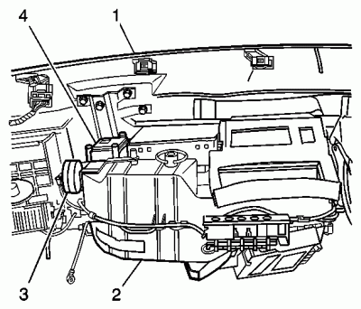
Click to Enlarge
- Disconnect all of the electrical connectors from the heat/vent module.
- Disconnect all of the vacuum lines from the heater/vent module.
- Disconnect the heater hoses from the heater core.
- Remove the heat/vent module (2) from the vehicle.
Installation Procedure
Click to Enlarge
- If replacing the heat/vent module, transfer the components from the old heat/vent module as necessary.
NOTE
Important: Before installing the heat/vent module to the vehicle, ensure that the heat/vent module mounting studs are located in the proper positions.
- Install the heat/vent module (2) to the vehicle.
- Connect the heater hoses to the heater core.
- Connect all of the vacuum lines to the heater/vent module.
- Connect all of the electrical connectors to the heat/vent module.
Click to Enlarge
- Install the bottom right heat/vent module mounting bolt from inside the vehicle approximately halfway into the threads.
NOTE
Notice: Use the correct fastener in the correct location. Replacement fasteners must be the correct part number for that application. Fasteners requiring replacement or fasteners requiring the use of thread locking compound or sealant are identified in the service procedure. Do not use paints, lubricants, or corrosion inhibitors on fasteners or fastener joint surfaces unless specified. These coatings affect fastener torque and joint clamping force and may damage the fastener. Use the correct tightening sequence and specifications when installing fasteners in order to avoid damage to parts and systems.
- On the Utility only, install the heat/vent module mounting stud located at the lower left side of the heater core to heater hoses connection in the engine compartment.
Tighten
Tighten the heat/vent module mounting stud to 4.5 N·m (22 lb in).
- Raise the vehicle.
- On the Utility only, install the bottom right heat/vent mounting studs. Ask an assistant to pull the bottom right corner of the heat/vent module back from inside the vehicle.
Tighten
Tighten the heat/vent module mounting studs to 4.5 N·m (22 lb in).
- On the Utility only, install the A/C evaporator and blower module heat shield bracket.
- Install the heater/vent module mounting nuts.
Tighten
Tighten the heat/vent module mounting nuts to 4.5 N·m (22 lb in).
- On the Utility only, slide the A/C evaporator and blower module heat shield into the original position.
- On the Utility only, install the A/C evaporator and blower module heat shield screws.
Tighten
Tighten the A/C evaporator and blower module heat shield screws 2.2 N·m (19 lb in).
- Install the left front tire. Refer to Tire and Wheel Removal and Installation in Tires and Wheels.
- Lower the vehicle.
- Install the bottom left heat/vent module mounting bolt from inside the vehicle.
Tighten
Tighten the heat/vent module mounting bolt to 4.5 N·m (22 lb in).
- Install the left wheel house panel. Refer to Wheelhouse Panel Replacement in Body Front End.
- Install the heat/vent module mounting nut located at the lower left side of the heater core to heater connection.
Tighten
Tighten the heat/vent module mounting nut to 4.5 N·m (22 lb in).
- Install the heat/vent module mounting bolt located at the lower left side of the heater core to heater hose connection.
Tighten
Tighten the heat/vent module mounting bolt to 4.5 N·m (22 lb in).
NOTE
Important: Use the same mounting bolt marked during removal for the heater/vent module during the installation process. Other mounting bolts are longer and will obstruct the operation of the temperature door.
- Install the heat/vent module mounting bolt through the blower motor resistor or service access cover opening.
Tighten
Tighten the heat/vent module mounting bolt to 4.5 N·m (22 lb in).
- On vehicles without automatic climate control, install the blower motor resistor.
Click to Enlarge
- On vehicles with automatic climate control only, install the service access cover (2).
- On vehicles with automatic climate control only, install the service access cover mounting screws (1).
Tighten
Tighten the screws to 1.9 N·m (17 lb in).
- Install the outer layer of the A/C evaporator and blower module.
NOTE
Important: Do not use RTV. Apply the adhesive bead as straight as possible. Allow the adhesive to set for 15 minutes or until the adhesive becomes tacky.
- Seal the cut line using black weather-strip adhesive.
- Refill the engine coolant. Refer to Cooling System Draining and Filling in Engine Cooling.
- Install the instrument panel. Refer to Instrument Panel Carrier Replacement in Instrument Panel, Gages and Console.

Heater Core Replacement

Heater Core Replacement
Removal Procedure
- Remove the heater/vent module. Refer to Heater/Vent Module Replacement .
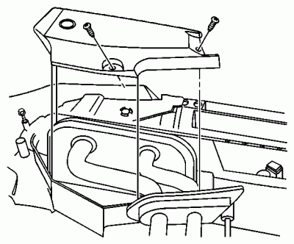
Click to Enlarge
- Remove the heater core access cover screws.
- Remove the heater core access cover.
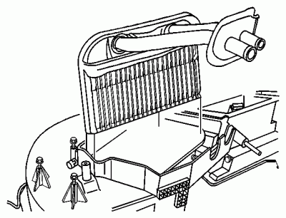
Click to Enlarge
- Remove the heater core from the heater/vent module.
Installation Procedure
Click to Enlarge
- Install the heater core to the heater/vent module.
Click to Enlarge

NOTE
Notice: Use the correct fastener in the correct location. Replacement fasteners must be the correct part number for that application. Fasteners requiring replacement or fasteners requiring the use of thread locking compound or sealant are identified in the service procedure. Do not use paints, lubricants, or corrosion inhibitors on fasteners or fastener joint surfaces unless specified. These coatings affect fastener torque and joint clamping force and may damage the fastener. Use the correct tightening sequence and specifications when installing fasteners in order to avoid damage to parts and systems.
- Install the heater core access cover.
Tighten
Tighten the heater core access cover screws to 1.9 N·m (17 lb in).
- Install the heater/vent module. Refer to Heater/Vent Module Replacement .

Heater Core Replacement
Removal Procedure
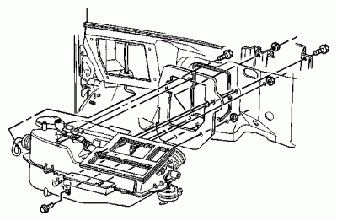
Click to Enlarge
- Drain the engine coolant. Refer to Cooling System Draining and Filling in Engine Cooling.
- Remove the instrument panel. Refer to Instrument Panel Carrier Replacement in Instrument Panel, Gages and Console.
- Remove the evaporator case assembly. Refer to Air Conditioning Evaporator Core Replacement .
- Remove the heater hoses from heater core. Refer to the following procedures:
  - Heater Inlet Hose Replacement
  - Heater Outlet Hose Replacement
- Disconnect the electrical connector from the HVAC vacuum control valve.
- Disconnect the electrical connector from the body control module.
- Disconnect vacuum source hose from the hose leading to the HVAC vacuum control valve.
- Remove the heater case retaining screws.
- Remove the heater case assembly from vehicle.
- Remove the heater core access cover screws.
- Remove the heater core access cover.
- Remove the heater core from the heater case.
Installation Procedure
Click to Enlarge
- Install the heater core to the heater case.
- Install the heater core access cover to the heater case.
NOTE
Notice: Use the correct fastener in the correct location. Replacement fasteners must be the correct part number for that application. Fasteners requiring replacement or fasteners requiring the use of thread locking compound or sealant are identified in the service procedure. Do not use paints, lubricants, or corrosion inhibitors on fasteners or fastener joint surfaces unless specified. These coatings affect fastener torque and joint clamping force and may damage the fastener. Use the correct tightening sequence and specifications when installing fasteners in order to avoid damage to parts and systems.
- Install the heater core access cover retaining screws.
Tighten
Tighten the heater core access cover screws to 1.9 N·m (17 lb in).
- Install the heater case to the vehicle.
- Install the heater case retaining nuts and bolts.
Tighten
Tighten the heater case retaining nuts and bolts to 4.5 N·m (40 lb in).
- Connect the vacuum source hose to the hose leading to the HVAC vacuum control valve.
- Connect the electrical connector to the body control module.
- Connect the electrical connector to the HVAC vacuum control valve.
- Install the heater hoses to the heater core. Refer to the following procedures:
  - Heater Inlet Hose Replacement
  - Heater Outlet Hose Replacement
- Install the evaporator case assembly. Refer to Air Conditioning Evaporator Core Replacement .
- Remove the instrument panel. Refer to Instrument Panel Carrier Replacement in Instrument Panel, Gages and Console.
- Refill the engine cooling system. Refer to Cooling System Draining and Filling in Engine Cooling.
- Check the cooling system for leaks.

